Work Done This Week
During Week 2, I worked on data collection, cleaning, and preprocessing of the DataCo Supply Chain dataset for logistics analysis.
The following activities were completed:
- Data Collection and Inspection: Loaded the DataCo Supply Chain dataset into Google Colab and inspected its structure, rows, columns, and data types. The initial dataset contained 41,653 rows and 52 columns.
Figure1: Initial Dataset Dimensions
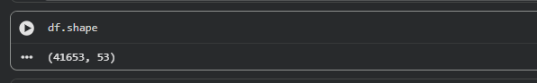
- Missing Value Analysis: Checked the dataset for missing values. A total of 17 missing values were identified across different columns.
Figure2: Missing Value Analysis Before Cleaning
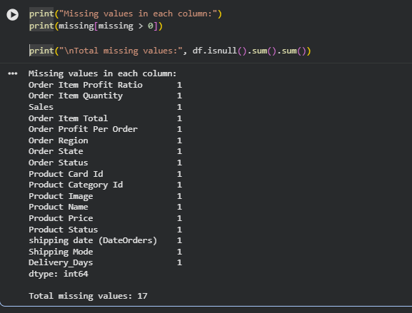
- Missing Value Handling: Removed the incomplete records because the number of missing records was very small compared with the overall dataset. After cleaning, there were 0 missing values.
- Duplicate Check: Checked the dataset for duplicate rows. No duplicate records were found.
- Date Preprocessing: Converted the Order Date and Shipping Date columns into the appropriate datetime format.
- Delivery Days Analysis: Created and checked the Delivery_Days variable to represent the delivery duration.
- Outlier Detection: Applied the IQR method to check for outliers in Delivery_Days. No outliers were detected.
Figure3: Outlier Detection Using IQR Method
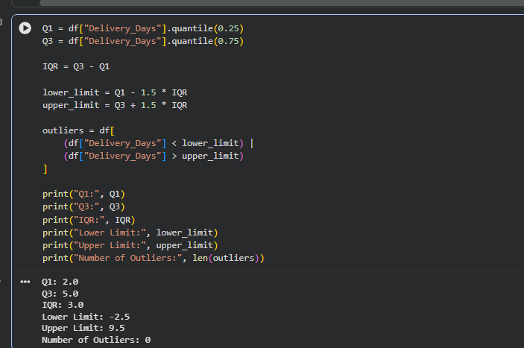
- Data Normalization: Applied Min-Max Scaling to selected numerical variables: Sales, Order Item Quantity, and Order Item Discount.
Figure4: Normalization On Numerical Variables
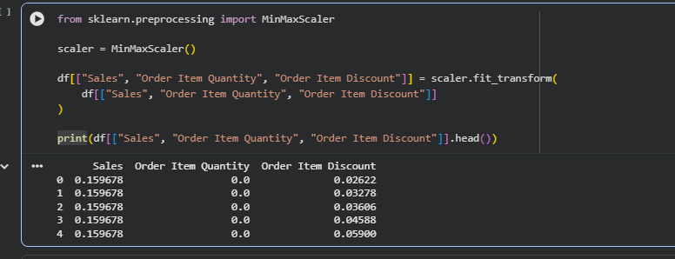
- Final Validation: After preprocessing, the final dataset contained 41,652 rows and 52 columns, with 0 missing values and 0 duplicate rows.
Figure5: Final Data Quality Validation
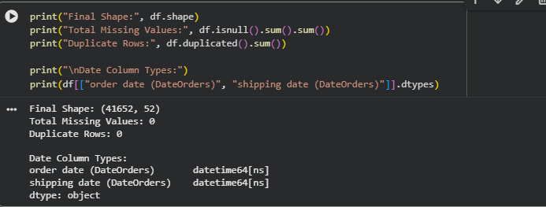
- Dataset Export: Saved the cleaned and preprocessed dataset as DataCo_Cleaned_Preprocessed.csv for further logistics analysis.
- Conclusion: The DataCo Supply Chain dataset was successfully cleaned and preprocessed. Missing values and duplicate records were checked, date columns were converted, delivery duration was examined, outliers were evaluated using the IQR method, and selected numerical variables were normalized. The resulting cleaned dataset is ready for further logistics analysis and visualization.

